**Experiment No. 5 :*****Basic Scripts***

***b) (i) Write a shell script to perform arithmetic operations.***

$ x=8

y=2

echo "x=8, y=2"

echo "Addition of x & y"

echo $(( $x + $y ))

echo "Subtraction of x & y"

echo $(( $x - $y ))

echo "Multiplication of x & y"

echo $(( $x * $y ))

echo "Division of x by y"

echo $(( $x / $y ))

**OUTPUT-**

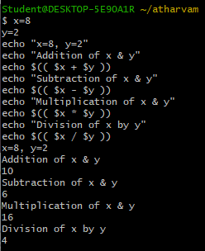 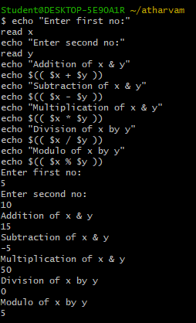

***ii) Write a shell script to calculate simple interest.***

echo "Enter prinicpal amount:"

read p

echo "Enter time period:"

read t

echo "Enter rate of interest:"

read i

si=` expr $p \* $t \* $i `

si=` expr $si / 100 `

echo "Simple interest is: $si"

**OUTPUT-**

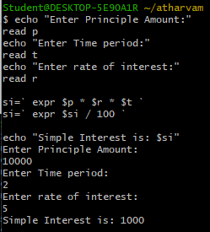

***iii) Write a shell script to determine largest among three integer numbers.***

***3) if (a>b) ? (a>c ? a : c) : (b>c ? b :c)***

#!/bin/bash

echo "Enter three numbers:"

read a b c

if [ $a -gt $b ] && [ $a -gt $c ]

then

echo "$a is the largest."

elif [ $b -gt $a ] && [ $b -gt $c ]

then

echo "$b is the largest."

else

echo "$c is the largest."

fi

**OUTPUT-**

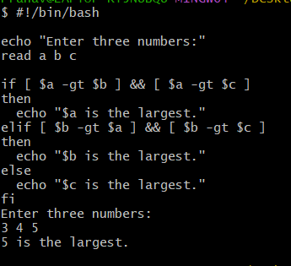

***(iv) Write a shell script to determine a given year is leap year or not.***

echo "TO FIND LEAP YEAR"

echo -n "Enter a year:"

read year

if [ `expr $year % 4` -eq 0 ]

then

echo "Entered year is a leap year"

else

echo "Entered year is not a leap year"

fi

**OUTPUT-**

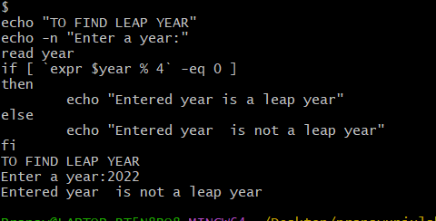

***v) Write a shell script to print multiplication table of given number using while statement.***

echo "Enter the number -"

read n

i=1

while [ $i -le 10 ]

do

res=`expr $i \* $n`

echo "$n * $i = $res"

((++i))

done

**OUTPUT-**

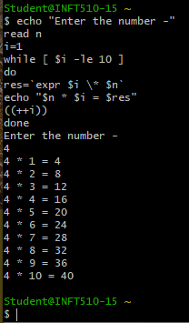

**(vi) Write a shell script to search whether element is present is in the list or not.**

**#!/bin/sh**

**list=(element1 element2 element3 element4)**

**if [[ " ${list[*]} " == *" element3 "* ]]; then**

**echo "Element found in the list"**

**else**

**echo "Element not found in the list"**

**fi**

**OUTPUT-**

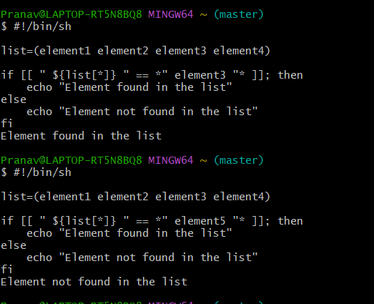

***vii) Write a shell script to compare two strings.***

read -p "Enter two strings: " str1 str2

if [ $str1 == $str2 ]

then

echo "Strings are Equal"

else

echo "Strings are Unequal"

fi

**OUTPUT-**

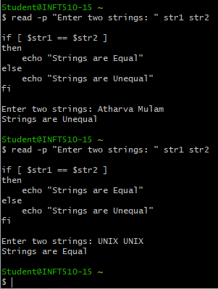

**(viii) Write a shell script to read and check if the directory / file exists or not, if not make the directory / file.**

#!/bin/sh

path="/path/to/directory_or_file"

if [ ! -e "${path}" ]; then

mkdir -p "${path}"

echo "Directory/File created"

else

echo "Directory/File already exists"

fi

**OUPUT-**

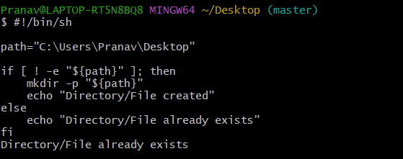

**(ix) Write a shell script to implement menu-driven calculator using case statement.**

echo "Enter 1st number:"

read num1

echo "Enter 1st number:"

read num2

echo "Menu:"

echo "1. Add"

echo "2. Subtract"

echo "3. Multiply"

echo "4. Divide"

echo "5. Quit"

while true

do

echo "Enter your choice:"

read choice

case $choice in

1) $(( $num1 + $num2)) ;;

2) $(( $num1 - $num2)) ;;

3) $(( $num1 * $num2)) ;;

4) $(( $num1 / $num2)) ;;

5) exit ;;

*) echo "Invalid choice. Please try again." ;;

esac

done

**OUTPUT-**

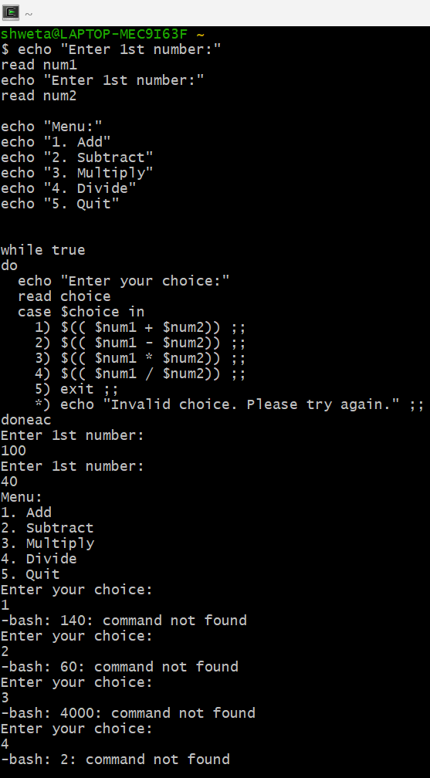

(x) Write a shell script to print following pattern

Code:

#!/bin/sh

for i in $(seq 1 4); do

for j in $(seq 1 ${i}); do

echo -n "* "

done

echo ""

done

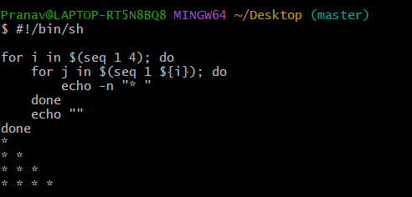

**~~~~~~~~~~~~~~~~~~~~~~~~~~~~~~~~~~~~~~~~~~~~~~~~~~~~~~~~~~~~~~~~~~~~~~~~~~~~~~~~**

**Experiment No. 6 :*****Advanced Scripts***

***a) Execute the following scripts using grep / sed commands:***

***(i) Write a script using grep command to find the number of words character, words and lines in a file.***

grep -o . demo1.txt | wc -c && grep -o " " demo1.txt | wc -w && wc -l < demo1.txt

**OUTPUT-**

**Output will be of the form:**

NUMBER_OF_CHARACTERS

NUMBER_OF_WORDS

NUMBER_OF_LINES

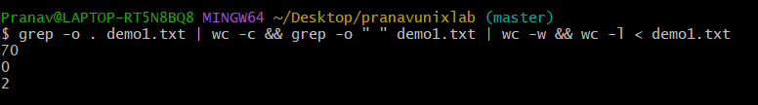

**(ii) Write a script using egrep command to display list of specific type of files in the directory.**

Code:

ls | egrep '\.(txt|pdf|docx)$'

Output:

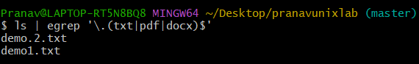

***(iii) Write a script using sed command to replace all occurrences of particular word in a given file.***

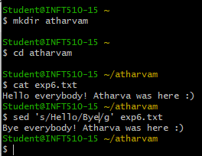

**(iv) Write a script using sedcommand to print duplicated lines in input.**

#!/bin/bash

echo "Enter input:"

read input

echo "Duplicated lines in input:"

echo "$input" | sed -n 'G; s/\n/&&/; /^\([ -~]*\n\).*\n\1/d; s/\n//; h; P'

***b) Execute the following scripts using awk / perl languages:***

***(i) Write an awk script to print all even numbers in a given range.***

**seq 1 10 | awk '{if($1%2==0) print $1}'**

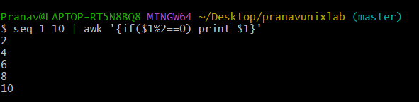

***(ii) Write an awk script to develop a Fibonacci series (take user input for number of terms).***

***CODE-***

awk 'BEGIN{a=0;b=1;print a;print b;for(i=0;i<10;i++){c=a+b;print c;a=b;b=c}}'

**OUTPUT-**

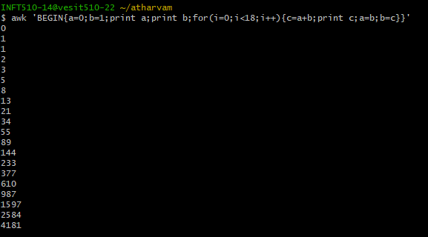

***(iii) Write a perl script to sort elements of an array.***

**Executed on VMWare workstation-**

#!/usr/bin/perl

my @numbers = (4, 2, 6, 1, 8, 3, 7, 5);

@numbers = sort {$a <=> $b} @numbers;

print "@numbers\n";

**OUTPUT-**



***(iv) Write a perl script to check a number is prime or not.***

***CODE-***

print "Enter a number: ";

$n=<>;

$d=0;

if($n==2)

{

print "Prime number.n";

}

else

{

for($c=2;$c<=$n-1;$c++)

{

if($n%$c==0)

{

$d=1;

break;

}

}

if($d==1)

{

print "Number is not prime!\n";

}

else

{

print "Number is prime!\n";

}

}

**OUTPUT-**

